1.1 Project Architecture Diagram

1.2

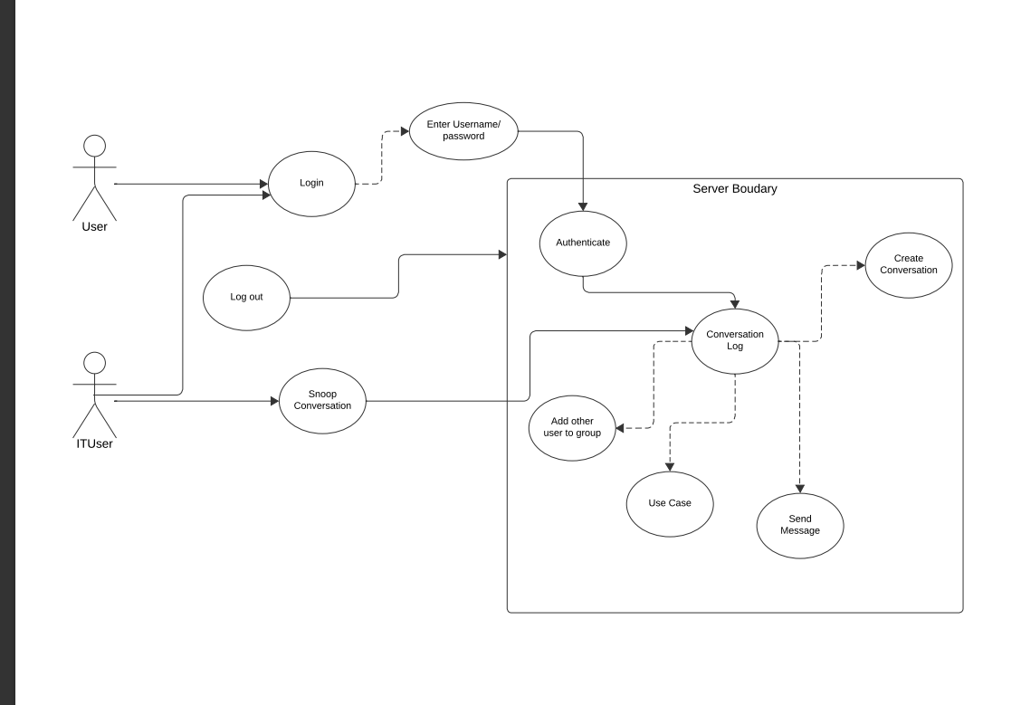

1.3 Client Side GUI Use Cases

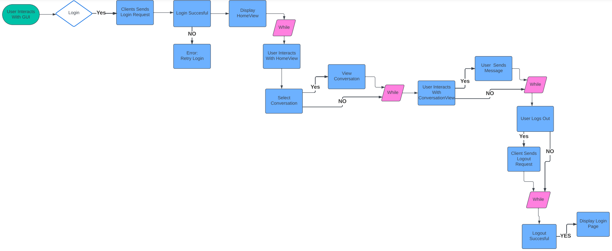

1.4 Bird’s Eye Perspective Use Cases

1.5 Client Login and Send Message Use Cases (Server Perspective)

